Eligible to take student(s): 
For the latest info, please refer to https://tigpbio.programs.sinica.edu.tw/faculty.html

Graduate Institute of Biomedical Electronics and Bioinformatics, National Taiwan University
國立臺灣大學 生醫電子與資訊學研究所

Dr. Chung-Ping Chen 陳中平 
cpchen@ntu.edu.tw 
Students:
● Statistical Timing Analysis
● Circuit Simulation and Optimization
● Microprocessor Design
Graduate Institute of Biomedical Electronics and Bioinformatics, National Taiwan University
國立臺灣大學 生醫電子與資訊學研究所
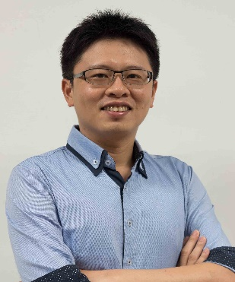
Dr. Nien-Tsu Huang 黃念祖 
nthuang@ntu.edu.tw 
Students:
● developing integrated electrical, optical and mechanical miniaturized fluidics and sensors for biological applications, such as cellular biology, drug screening, and disease diagnosis

Graduate Institute of Biomedical Electronics and Bioinformatics, National Taiwan University
國立臺灣大學 生醫電子與資訊學研究所
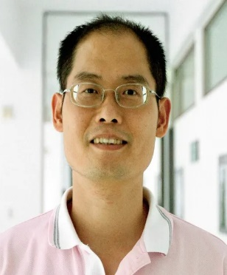
Dr. Po-Ling Kuo 郭柏齡
poling@ntu.edu.tw
Students:
● Biophysics
● Mechanobiology
● Biomechanics
Graduate Institute of Physiology, National Taiwan University
國立臺灣大學 生理學研究所
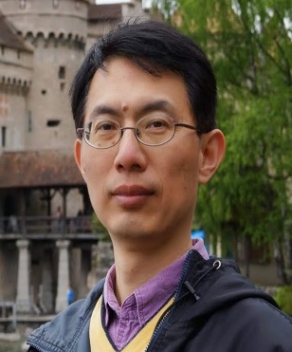
Dr. Liang-Chuan Lai 賴亮全
llai@ntu.edu.tw
Students:
● using microarray or next generation sequencing to explore the cancer genomics
● Investigation of regulatory mechanism of NDRG1 upon reoxygenation
● Regulation of transcription and metastasis of semaphorin family in lung cancer

Institute of Health Data Analytics and Statistics, National Taiwan University
國立臺灣大學 健康數據拓析統計研究所
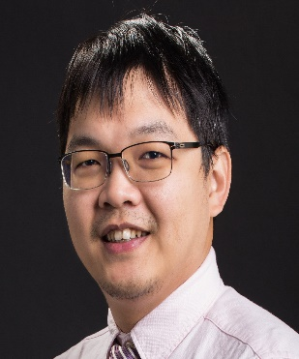
Dr. Tzu-Pin Lu 盧子彬
tplu@ntu.edu.tw
Students:
● Bioinformatics
● Microarray and next generation sequencing data analysis
● Computational Biology
Graduate Institute of Biomedical Electronics and Bioinformatics, National Taiwan University
國立臺灣大學 生醫電子與資訊學研究所

Dr. Yufeng Jane Tseng 曾宇鳳
yjtseng@csie.ntu.edu.tw
Students:
● Computational Chemistry and Toxicology
● Metabolomics
● Bioinformatics
● Cheminformatics
● Health informatics

Department of Biomechatronics Engineering, National Taiwan University
國立臺灣大學 生物機電工程學系

Dr. Chien-Yu Chen 陳倩瑜
chienyuchen@ntu.edu.tw
Students:
● Bioinformatics
● Data Mining
● Machine Learning
Graduate Institute of Biomedical Electronics and Bioinformatics, National Taiwan University
國立臺灣大學 生醫電子與資訊學研究所
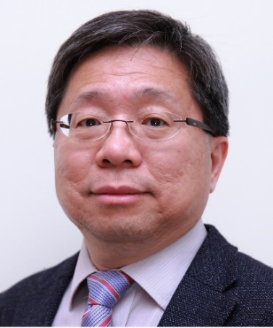
Dr. Eric Y. Chuang 莊曜宇
chuangey@ntu.edu.tw
Students: Chayanika Goswami
● Biochip Bioinformatics
● Next-Generation Sequencing
● Radiation Biology
● Cancer Biology
● Bioinformatics

Institute of Biotechnology, National Taiwan University
國立臺灣大學 生物科技研究所
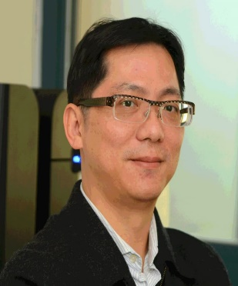
Dr. Mon-Hsun Tsai 蔡孟勳
motiont@gmail.com
Students:
● Bioinformatics
● Cell Biology
● Microarray
● Radiation Biology
Institute of Molecular and Cellular Biology, National Taiwan University
國立臺灣大學 分子與細胞生物學研究所
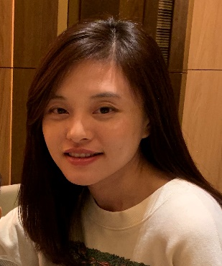
Dr. Hsiao-Chun Huang 黃筱鈞
hsiaochun@ntu.edu.tw
Students: Ya-Chu Hsu
● Molecular Cell Biology
● Systems and Synthetic Biology
● Cell Division

Department of Life Science, National Taiwan University
國立臺灣大學 生命科學系
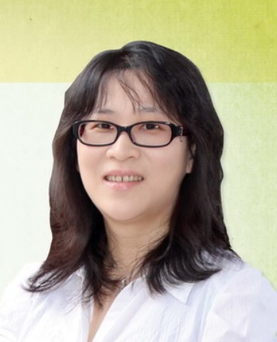
Dr. Hsueh-Fen Juan 阮雪芬
yukijuan@ntu.edu.tw
Students:
● Genomics
● Bioinfomatics
● Proteomics
Graduate Institute of Biomedical Electronics and Bioinformatics, National Taiwan University
國立臺灣大學 生醫電子與資訊學研究所
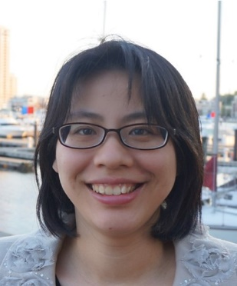
Dr. An-Chi Wei 魏安祺
acwei86@ntu.edu.tw
Students:
● System Biology
● Modeling and Simulation of biological systems
● Bioenergetics and Metabolism
● Mitochondria

The Graduate Institute of Medical Genomics and Proteomics, National Taiwan University
國立臺灣大學 基因體暨蛋白體醫學研究所
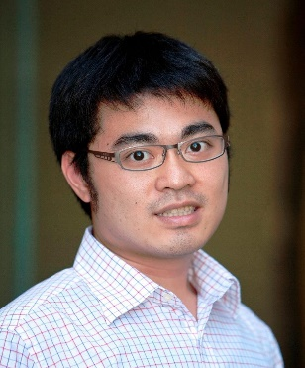
Dr. Shu-Jui Hsu 許書睿
jacobhsu@ntu.edu.tw
Students: Daniel Nelson
● Human Genomics
● Statistical Genetics
● Bioinformatics
● Genome Medicine
Electrical Engineering Department, National Taiwan University
國立臺灣大學 電機工程學系
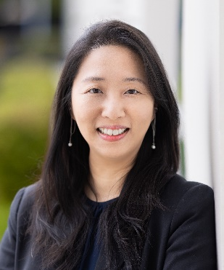
Dr. Tzu-Yu (Joyce) Liu 劉子毓
joyliu@ntu.edu.tw
Students:
● Functional data analysis
● Transfer learning
● Multi-task learning
● Data fusion
● Generative model

Master's Program in Smart Medicine and Health Informatics, National Taiwan University
國立臺灣大學 智慧醫療與健康資訊碩士學程
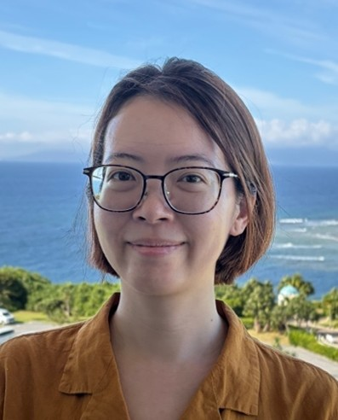
Dr. Fei-Man Hsu 徐翡曼
feimanh@ntu.edu.tw
Students:
● Epigenomics and Genomics
● Bioinformatics
● Disease biomarkers
Department of Computer Science and Information Engineering, National Taiwan University
國立臺灣大學 資訊工程學系暨研究所
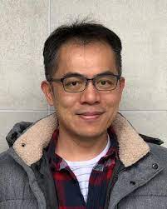
Dr. Hsuan-Cheng Huang 黃宣誠
hsuancheng@ntu.edu.tw
Students: Ping-Yun Ou, Ching-Ya Lin
● Networks biology
● Systems biology
● Bioinformatics

