Graduate Institute of Biomedical Electronics and Bioinformatics, National Taiwan University
國立台灣大學 生醫電子與資訊學研究所
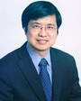
Dr. Chung-Ping Chen 陳中平
cpchen@ntu.edu.tw
Students:
● Statistical Timing Analysis
● Circuit Simulation and Optimization
● Microprocessor Design

Graduate Institute of Biomedical Electronics and Bioinformatics, National Taiwan University
國立台灣大學 生醫電子與資訊學研究所
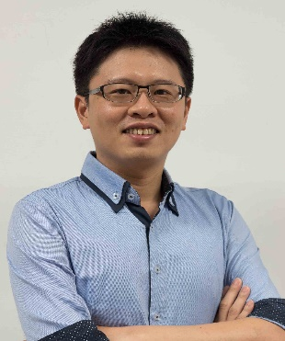
Dr. Nien-Tsu Huang 黃念祖
nthuang@ntu.edu.tw
Students:
● developing integrated electrical, optical and mechanical miniaturized fluidics and sensors for biological applications, such as cellular biology, drug screening, and disease diagnosis

Graduate Institute of Biomedical Electronics and Bioinformatics, National Taiwan University
國立台灣大學 生醫電子與資訊學研究所
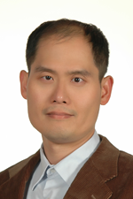
Dr. Po-Lin Kuo 郭柏齡
poling@ntu.edu.tw
Students:
● Biophysics
● Mechanobiology
● Biomechanics

Graduate Institute of Biomedical Electronics and Bioinformatics, National Taiwan University
國立台灣大學 生理學研究所
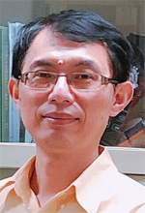
Dr. Liang-Chuan Lai 賴亮全
llai@ntu.edu.tw
Students:
● using microarray or next generation sequencing to explore the cancer genomics
● Investigation of regulatory mechanism of NDRG1 upon reoxygenation
● Regulation of transcription and metastasis of semaphorin family in lung cancer

Graduate Institute of Biomedical Electronics and Bioinformatics, National Taiwan University
國立台灣大學 流行病學與預防醫學研究所
Dr. Tzu-Pin Lu 盧子彬
tplu@ntu.edu.tw
Students:
Yu-Ching Hsu
● Bioinformatics
● Microarray and next generation sequencing data analysis
● Computational Biology

Graduate Institute of Biomedical Electronics and Bioinformatics, National Taiwan University
國立台灣大學 生醫電子與資訊學研究所
Dr. Tseng, Y. Jane 曾宇鳳
yjtseng@csie.ntu.edu.tw
Students:
● Computational Chemistry and Toxicology
● Metabolomics
● Bioinformatics
● Cheminformatics
● Health informatics

Graduate Institute of Biomedical Electronics and Bioinformatics, National Taiwan University
國立台灣大學 生物產業機電工程學系
Dr. Chien-Yu Chen 陳倩瑜
chienyuchen@ntu.edu.tw
Students:
● Bioinformatics
● Data Mining
● Machine Learning

Graduate Institute of Biomedical Electronics and Bioinformatics, National Taiwan University
國立台灣大學 生醫電子與資訊學研究所
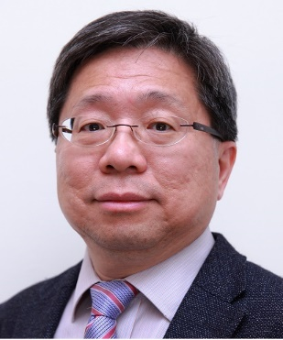
Dr. Eric Y. Chuang 莊曜宇
chuangey@ntu.edu.tw
Students:
Nhut Nam Phan
● Biochip Bioinformatics
● Next-Generation Sequencing
● Radiation Biology
● Cancer Biology
● Bioinformatics

Graduate Institute of Biomedical Electronics and Bioinformatics, National Taiwan University
國立台灣大學 生命科學系
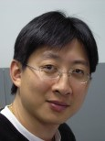
Dr. Hsin-Yu Lee 李心予
hsinyu@ntu.edu.tw
Students:
● Cellular Biology
● Molecular Biology
● Endocrinology

Graduate Institute of Biomedical Electronics and Bioinformatics, National Taiwan University
國立台灣大學 醫學系麻醉科
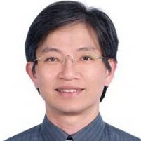
Dr. Wei-Zen Sun 孫維仁
wzsun@ntu.edu.tw
Students:
● Pain medicine
● acupuncture and moxibustion
● anesthesiology

Graduate Institute of Biomedical Electronics and Bioinformatics, National Taiwan University
國立台灣大學 生物科技研究所
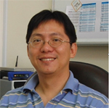
Dr. Mon-Hsun Tsai 蔡孟勳
motiont@gmail.com
Students:
● Bioinformatics
● Cell Biology
● Microarray
● Radiation Biology

Graduate Institute of Biomedical Electronics and Bioinformatics, National Taiwan University
國立台灣大學 動物科學技術學系
Dr. En-Chung Lin 林恩仲
eclin01@ntu.edu.tw
Students:
● Functional Genomics and Proteomics
● Bioinfomatics
● Statistical Biology
● Management and Reproduction of Transgenic Animal Science

Graduate Institute of Biomedical Electronics and Bioinformatics, National Taiwan University
國立台灣大學 分子與細胞生物學研究所所
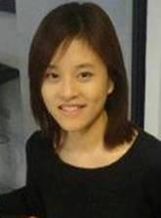
Dr. Hsiao-Chun Huang 黃筱鈞
hsiaochun@ntu.edu.tw
Students:
● Molecular Cell Biology
● Systems and Synthetic Biology
● Cell Division

Graduate Institute of Biomedical Electronics and Bioinformatics, National Taiwan University
國立台灣大學 生命科學系
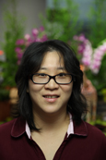
Dr. Hsueh-Fen Juan 阮雪芬
yukijuan@ntu.edu.tw
Students:
● Genomics
● Bioinfomatics
● Proteomics

Graduate Institute of Biomedical Electronics and Bioinformatics, National Taiwan University
國立台灣大學 生醫電子與資訊學研究所
Dr. Ruey-Feng Chang 張瑞峰
rfchang@csie.ntu.edu.tw
Students:
● Medical Image Processing
● Medical Image Analysis
● Computer-aided Diagnosis
● Computer-aided Detection
● Deep Learning
● Medical Ain

Graduate Institute of Biomedical Electronics and Bioinformatics, National Taiwan University
國立台灣大學 生醫電子與資訊學研究所
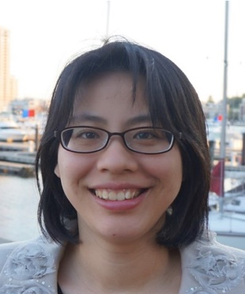
Dr. An-Chi Wei 魏安祺
acwei86@ntu.edu.tw
Students:
● System Biology
● Modeling and Simulation of biological systems
● Bioenergetics and Metabolism
● Mitochondria

